L. Young’s work

(Young et al., 1986): Nine cropping treatments were compared in fields infested with Heterodera glycines (SCN) in Arkansas, Missouri, and Tennessee, USA, from 1979 to 1984. The races in the three fields were likely to be 14. Bedford (derived from Peking + PI 88788, but probably only carrying PI 88788 resistance), PI 88788, and Nathan (similar to Bedford) selected nematodes that can develop on PI 88788. “SCN that cannot reproduce on resistant cultivars are believed to have greater fecundity than SCN that can reproduce on resistant cultivars. Thus growing a susceptible cultivar would maintain a field population with a grater percentage of SCN that cannot reproduce on resistant cultivars that would occur if the susceptible cultivar were not grown.”

(Young and Hartwig, 1992): (same field in Young et al. 1986) Nine soybean (Glycine max) cropping sequences were compared for 11 yr in a field infested with the soybean cyst nematode (SCN), Heterodera glycines, Woodland Hills, Tennessee . Inititonal race was probably 14. Similar result as in (Young et al., 1986). The most notable effect of continuous cropping of resistant soybean was the increased reproduction of the SCN population on resistant Bedford relative to reproduction on susceptible Essex. Blending or rotation with susceptible soybean slowed increase in FI.

(Young, 1994b): “Combined work of several workers demonstrated that course of H. glycines resistance genes can be placed into genetic groups. One group consists of Peking, PI 89772, and PI 90763, and the other group contains cloud, PI 87631-1, PI 88788, and PI 209332.” (same field in Young et al. 1986) (Young et al., 1986) in Tennessee. Regression and cluster analysis determine FI = a + bx, where x is time.

(Young, 1998): Jackson, Tennesssee, Several soyabean cropping sequences were planted for 12 years in a field that, at the beginning of the test, was infested with race 14 of Heterodera glycines. Soybean carrying PI 88788 (Bedford) increased reproduction of the SCN on PI 88788. Soybean carrying Peking resistance did not increase reproduction. Rotations of soybean cultivars with different sources of resistance and rotations of resistant and susceptible cultivars with a nonhost crop were not successful practices to manage the nematode's ability to parasitize the resistant cultivar Bedford. However, rotation of resistant and susceptible cultivars with a nonhost crop produced greater mean soybean yields and slowed the shift toward greater parasitism of the resistant cultivar sufficiently to warrant adoption of this practice
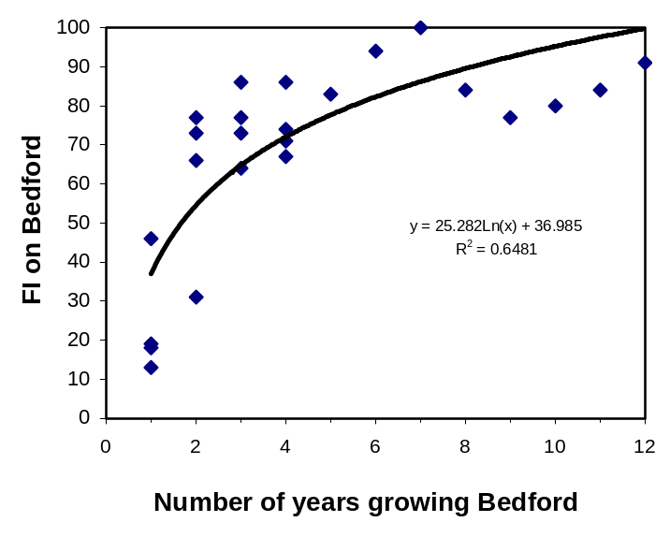
Fig. Reproduction ability (FI) increased over years on Bedford (carrying PI 88788) over years. The original population was race 14 to which Bedford was moderately resistant (Young, 1998).

(Young, 1984b): 17 SCN populations from fields with 3-6 years of continuous SCN-resistant soybean were evaluated for their reproductive ability on a number of resistant cuttivars. Survey, not plot experiments

(Young, 1982): Three race 4 field populations were challenged by soybean cultivars for 7 and 11 generations in greenhouse. PI 88788 and cultivars carrying PI 88788 selected increased FI on these cultivars, and Peking, its cultivars and PI 89772, and PI 90763 select SCN that can develop on these cultivars. The result indicates that Peking, PI 89722, and PI 90763 are correlated.

(Young, 1994a): Greenhouse study

(Young and Hartwig, 1988): It has been recommended that soyabean cultivars resistant to soyabean cyst nematode (SCN), Heterodera glycines, be rotated with susceptible cultivars in order to delay or avoid development of populations capable of damaging resistant cultivars. Trials were conducted following 10 years of such cropping sequences in Mississippi. Cropping sequences included susceptible Tracy and race 3 resistant Centennial (Peking source) grown consecutively with and without nematicide. Sequences of 2 years of Centennial and one year of Tracy, a blend of 80% Centennial and 20% Tracy, and a breeding line resistant to SCN races 3 and 4 planted consecutively were the other treatments. Lee, Pickett 71, Peking, PI88788, and PI90763 were grown in the greenhouse in soil from each field plot in 1985. Cyst indices (number of cysts relative to Lee) were calculated for these race differentials. Race 3 was predominant following consecutive plantings of either Tracy or the breeding line resistant to races 3 and 4. Race 2 was predominant in one of 3 treatments involving rotation with 2 years of Centennial and 1 year of Tracy. Cyst indices on Pickett 71 were large for cropping sequences involving Centennial and the blend of Centennial and Tracy. Cyst indices were variable on Peking, PI88788 and PI90763 for sequences involving Centennial, but indices were within a standard deviation of the description for race 4. No evidence for stabilizing selection sufficient to prevent race shifts in SCN populations through use of susceptible cultivars was obtained.

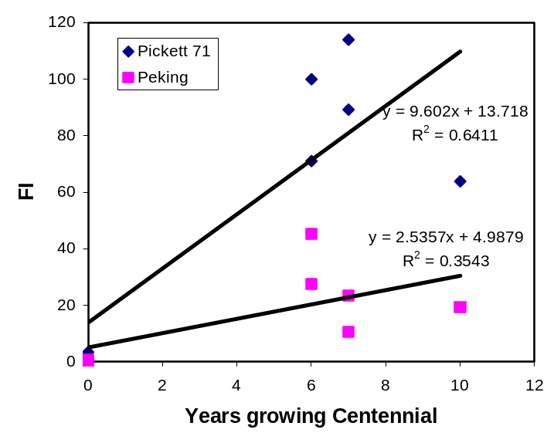
Fig. Increase of reproductive potential of SCN following growing Centennial soybean in a field with original race 3 in Mississippi.

Anand Work

(Anand and Shumway, 1985): Peking, PI 88788, and PI 90763 can select populations that increase reproductive ability on the selecting line and reduce reproductive ability on the other lines. The reduction of reproduction of Peking-selected population on PI 90763 or reproduction of PI 90763 on Peking was less than that in any combination with PI 88788, indicating Peking and PI 90763 have some common resistance. This study showed that cultivars derived from these resistance sources can be rotated to provide protection against SCN. Similar results were obtained in (Young, 1984a).

(Anand et al., 1995): Thirteen rotation treatments consisting of 'Bedford' (PI88788 RS), 'Forrest' resistant (Peking SR), 'Essex', and a nonhost crop were evaluated in an SCN infested field for 4 yr. Original population was race 14. Bedford select 2-3 years of Bedford selected SCN population that was capable to parasitize PI 88788: Changed race 14 to 4.

(Anand and Shumway, 1984): The 3 soybean cultivars, Custer, Pickett 71 and Forrest, which derived their resistance to race 3 of H. glycines from the variety Peking, were tested for their level of resistance. Similarly, Bedford, Nathan, D75-10710 and Bradley cultivars which are resistant to race 4 were compared against their donor parent PI 88788. Custer, Pickett 71, Forrest and Peking had equal levels of resistance to race 3 and all were equally susceptible to the culture developed on Forrest; however, Peking and Custer had fewer white females against PI 88788 culture than did those on Pickett 71 and Forrest. Among cultivars resistant to race 4, Nathan had a greater number of white females than PI 88788 on cultures developed on Essex, Bedford and Peking. In general, the derived cultivars had a greater number of white females/plant than their donor parents.

Riggs Work

Literature Cited

Anand, S. C., Koenning, S. R., and Sharma, S. B. 1995. Effect of temporal deployment of different sources of resistance to soybean cyst nematode. Journal of Production Agriculture 8:119-123.
Anand, S. C., and Shumway, C. R. 1984. Relative resistance of derived cultivars of soybeans to the cyst nematode, Heterodera glycines Ichinohe. Crop Protection 3:363-367.
Anand, S. C., and Shumway, C. R. 1985. Response of secondary selection on soybean cyst nematode reproduction on resistant soybean lines. Crop Protection 4:231-234.
Young, L. D. 1982. Reproduction of differentially selected soybean cyst nematode populations on soybeans Heterodera glycines. Crop Science 22:385-388.
Young, L. D. 1984a. Changes in the reproduction of Heterodera glycines on different lines of Glycine max. Journal of Nematology 16:304-309.
Young, L. D. 1984b. Effects of continuous culture of resistant soybean cultivars on soybean cyst nematode reproduction. Plant Disease 68:237-239.
Young, L. D. 1994a. Changes in reproduction of a Heterodera glycines Race-5 isolate cultured on 'Cordell' and 'Bedford' soybean. Journal of Nematology 26:653-655.
Young, L. D. 1994b. Changes in the Heterodera glycines female index as affected by ten-year cropping sequences. Journal of Nematology 26:505-510.
Young, L. D. 1998. Influence of soybean cropping sequences on seed yield and female index of the soybean cyst nematode. Plant Disease 82:615-619.
Young, L. D., and Hartwig, E. E. 1988. Selection pressure on soybean cyst nematode from soybean cropping sequences. Crop Science 28:845-847.
Young, L. D., and Hartwig, E. E. 1992. Cropping sequence effects on soybean and Heterodera glycines. Plant Disease 76:78-81.
Young, L. D., Hartwig, E. E., Anand, S. C., and Widick, D. 1986. Responses of soybeans and soybean cyst nematodes to cropping sequences. Plant Disease 70:787-791.

